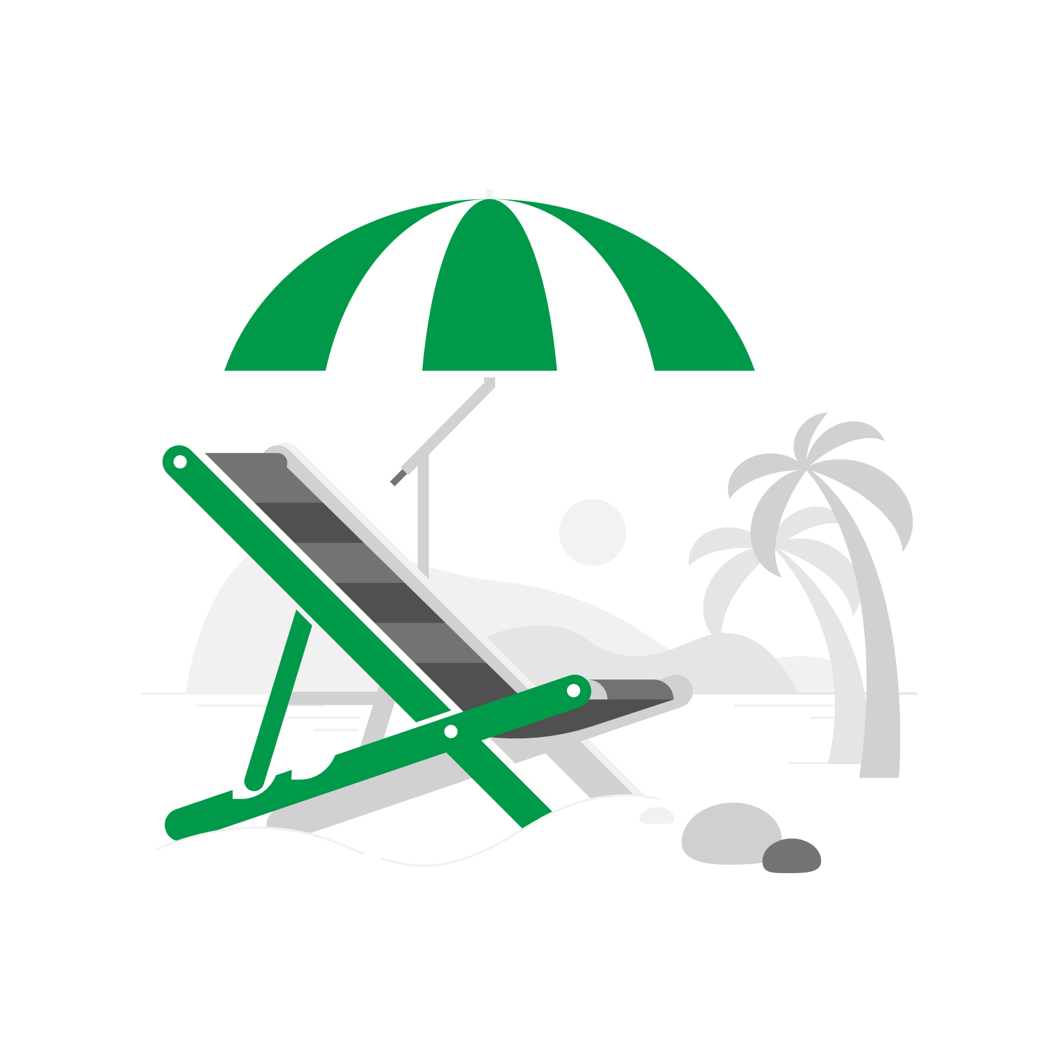
Summer Newsletter 2026
Friends and Family
Thanks to those of you who completed our Friends and Family survey last month.
Patients took the time to respond about your recent experience at the Practice- 97% rated us very good or good which is amazing to hear. Some our favourite comments were: Excellent service from both the reception team and the GP. Both were professional but also approachable and understanding. The practice physiotherapist answered all my questions clearly & suggested strengthening exercises to help alleviate some aspects of my kyphosis. From call to reception through to the end of my appointment, the staff were professional and personable I called up and was seen within the hour, I felt like I was taken seriously and the doctor took her time to explain everything

Travel Health Appointments Going on holiday soon.
Don’t forget your travel health appointment! If you’re planning a trip abroad, please make sure you book your travel advice and vaccination appointment early.
Why you need to plan ahead:
• Many travel vaccines need multiple doses over several weeks.
• Some vaccines are available on the NHS, but others must be arranged privately at a travel clinic.
• Certain destinations require specific vaccine courses that take time to complete.
When should you book?
Aim to contact us at least 6–8 weeks before you fly to make sure you have enough time for any required courses.

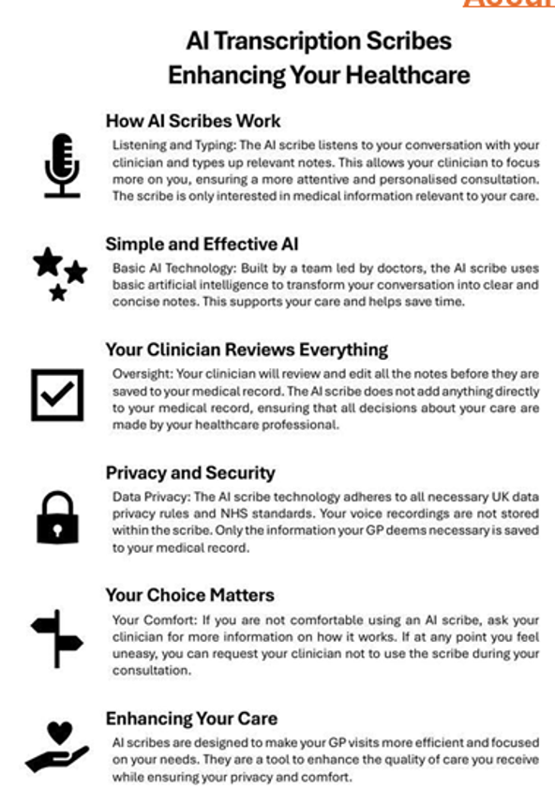
Accurx scribe At Great Ayton Health Centre
We are committed to providing high-quality care and making the best use of technology to enhance your experience during appointments.
One of the tools we may use in some consultations is Accurx Scribe. This secure, NHS-compliant tool helps document your consultation so your clinician can focus fully on you.
What can you expect?
• Consent first - your clinician will always ask before using the scribe
• Smart listening - the tool listens to the consultation and creates a summary for your medical record
• Clinician checked - your clinician reviews and verifies everything before it’s saved to ensure accuracy
Please note: Your clinician remains fully responsible for your care and for the accuracy of your notes.
NHS APP
You probably know about the NHS App – you might even be using it.
But have you turned on your notifications? Turning on your notifications means you'll see any messages we send immediately, rather than having to login to the app to see if we have sent you a message.
Messages received through the NHS App are free, so switching on notifications also helps NHS by saving SMS costs. Go to your device settings to change your notification preferences.

Calling all women experiencing perimenopause and menopause

We have been lucky enough to be selected to be involved with a pilot looking at women's health and in particular peri menopause and menopause.
Some of you may already have engaged with Harley St Menopause@home through their website. This would normally only be accessible to patients privately and we at Great Ayton Health Centre have been selected as one of only 100 GP surgeries in the country to be involved in this pilot.
In addition to allowing our female patients being able to access the huge amount of information/ webinars/ dietary advice / mental health support available through the website, we have been selected as one of only a few practices to be able to engage in a 10 week programme that focuses on improving women's health through supporting their GUT health with probiotics (Symprove ), Lipid lowering supplements like Benecol, Wellness support with specific dietary and exercise support tackling issues like pelvic floor support and weight gain around the menopause.
We know that our female population will be keen to participate in such a programme, which is investing in their longer-term health and look forwards to updating you in the near future as to when this will be launching.
  NHS Talking Therapies  If you’re struggling with a mental health condition like anxiety, OCD or PTSD then help is available.  NHS Talking Therapies are confidential and free treatments delivered by trained professionals, and can take place in person, on the phone or as an online course. You can refer yourself online at www.nhs.uk/talk |  | Community Pharmacy Services  When telephoning the surgery, you may be directed to the local pharmacy if we feel that you could be seen there.  Think Pharmacy First 'Think Pharmacy First' is an NHS campaign encouraging people to use their local pharmacy as the first point of contact for minor illnesses instead of going to a GP. Through the new Pharmacy First service, pharmacists can assess and treat seven common conditions without a GP appointment or prescription.  Patients can get advice or treatment for conditions such as  •sinusitis,  •sore throats,  •earaches,  •infected insect bites,  •impetigo,  •shingles, and  •uncomplicated UTIs in women.  All contraception pill requests will be directed to local pharmacists  If your condition is more serious or requires a different kind of care, the pharmacist will refer you to your GP or another appropriate service Many pharmacies are open in the evenings and on weekends, offering more convenient access than a GP appointment.  Long term condition reviews  If you have a long-term condition like Diabetes, Kidney problems, Asthma or High Blood Pressure, it is essential that we see you annually to review your condition, we will normally send you an invitation in the month of your birthday.  We aim to review all long-term conditions every 12months, with Diabetic patients being invited for an additional 6 monthly monitoring blood test.  When it is time for your review, the practice team will be in touch about making an appointment.  Please do respond to your invitation for your monitoring appointment. It is important we carry out these checks to ensure we keep you in the best health possible.  RSV Vaccines  The Respiratory Syncytial Virus (RSV) vaccine is a free, highly effective NHS immunization designed to protect vulnerable newborns and older adults from severe lung infections like pneumonia and bronchiolitis. A single dose provides long-term protection.    Who is Eligible?  You can get the RSV vaccine for free on the NHS if you meet the following criteria:  • Pregnant individuals: Offered from 28 weeks of pregnancy. It provides antibodies to the baby, protecting them from birth onwards.  • Older adults: Offered to everyone turning 75 or older  • Care home residents: Adults living in care homes for older adults.  Please book an appointment with the practice nurse if you are eligible.

